MS SQL SERVER
Standard Operating Procedures
(SOP)

SQL Server Log Monitoring 2014

Submitted to



By



CIS, Wipro Limited

Document Details

Project Name | Innogy SE
Account | CIS
IT Component/Application Title | SQL Server Log Monitoring 2014
Current Version | 1.6
List of Contributors | Pradipkumar Kansara, Kiran Bhalekar, Ayushi Gautam, Sivakumar Goud, Pramod Patil
Customer Contact Information

Version History
(All revisions made to this document must be listed in chronological order. All revisions must be approved. Review and Approval can be done by an internal source or by the customer)
Version | Date of Revision | Description | Author | Reviewed By | Approved By
1.0 | 29-08-2015 | Initial Draft | Ayushi Gautam | Pradipkumar Kansara | Mahesh Keshatwar
1.1 | 04-09-2015 | Document Completed | Kiran Bhalekar | Pradipkumar Kansara | Mahesh Keshatwar
1.2 | 21-08-2016 | Updated document to standard format | Kiran Bhalekar | Pradipkumar Kansara | Mahesh Keshatwar
1.3 | 17-05-2017 | Wipro and Innogy Logo changed | Siva Kumar Goud | Pradipkumar Kansara | Mahesh Keshatwar
1.4 | 18-08-2017 | Updated document to Wipro Standard format with header and footer | Ayushi Gautam | Pradipkumar Kansara | Santosh Badiger
1.5 | 29-11-2017 | Updated the document for 2014 version of SQL Server | Ayushi Gautam | Pradipkumar Kansara | Santosh Badiger
1.2 | 18-12-2018 | Updated the content | Pramod Patil | Pradipkumar Kansara | Santosh Badiger

Document Distribution List
Sr.No | Name and Company | Purpose
1 | RWEIT-SQLDBA | This document is about how to monitor log

TABLE OF CONTENT
1. Purpose 1
2. Scope 1
3. Sql Server Log Monitoring 1
3.1 Determining The Sql Server Log. 1
4. Reference 4

Purpose
This document is prepared for SQL Server Log Monitoring SQL Server Database.

Scope
This document is prepared for Wipro SQL team and provides the concepts of SQL Server Log Monitoring for the SQL Server database.

SQL Server Log Monitoring

3.1 Determining the SQL Server Log.
Step 1: To connect to the database server, go to

Start > Run

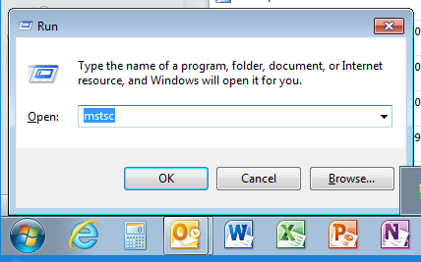

Step 2: Here type the command mstsc /console

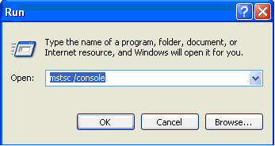

Step 3: Select the I.P. of the server to connect to.

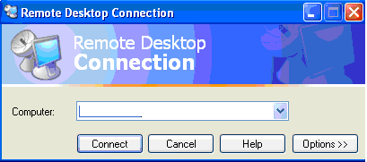
Enter the Server Name Here

Step 4: Enter the valid username and password to login to the database server.

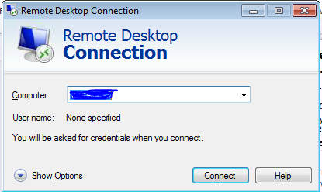

Step 5: Open the SSMS:

Go to Start > RUN > SSMS > SQL SERVER MANAGEMENT STUDIO

Step 6: In the left pane of the SSMS,

Go to SQL Server Agent > Error Logs > Current

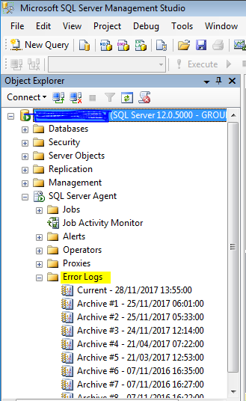

Check the log file for any errors.

Right click on Current > View Agent Log
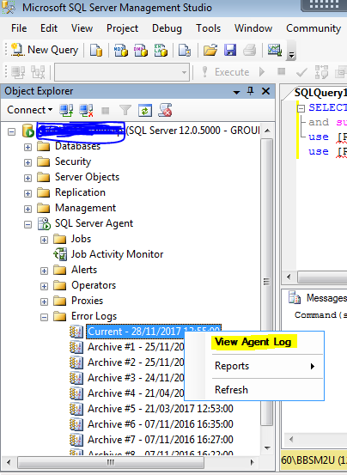

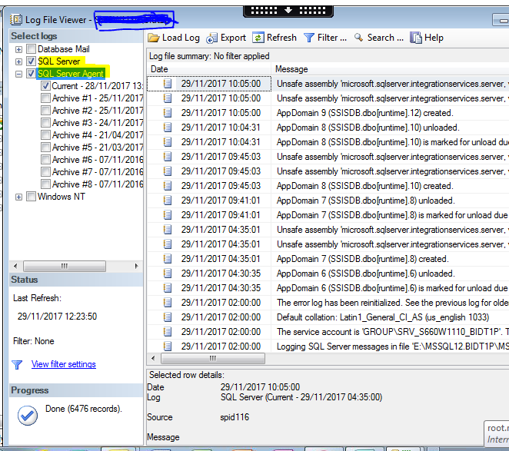

Reference
- http://msdn.microsoft.com/en-us/sqlserver/default.aspx

